Foreign Culture Presentation Report (20%)
One obvious form or preparation for an overseas job is learning about the local culture of your new location. This is exactly what we will do: the seminars will include 4-5 foreign culture reports that you will prepare in teams (with local colleagues). The reports will be in the form of a team presentation (4-5 students in a team), focusing on the essential information an expatriate needs to have with regard to the culture of a foreign location of your choice. Typically such reports focus on countries, but as we will discuss in this class, nations may or may not be the most relevant unit of analysis: any specific cultural space (country, region, city, etc.) will be accepted as the unit of analysis. Relevant issues to discuss include the following:
- A general description of the culture (e.g., cultural dimensions, religion and beliefs, language, etc.)
- Specifics of the political, economic, technological, and legal environment, as relevant
- Management practices prevalent in this culture (e.g., how are employees hired? promoted? motivated?)
- Skills and abilities that potential expatriates need in order to be successful in this culture
- Any other interesting and specific details that provide a good understanding of “how things work” in this cultural space
You may choose any foreign culture in the world, and that means none of the team members is familiar with this culture: choose a culture you all want to learn about. No team can choose a culture already taken by another team. This way we will cover a wide range of cultures – knowledge from multiple cultures contributes to the development of cultural intelligence.
Each foreign culture report will last not more than 20 minutes (time limit will be enforced, and a Feedback and Q&A session is included). The presentation will be informal, but it will include PowerPoint slides. Be creative and make use of visual aids (e.g., video clips, music, pictures, and any other artifacts) that can enhance the delivery of your material. Make your presentation fun and interactive!
Foreign Culture Reports are due on 10 June 2017.
For this task you will be evaluated by your peers based on three criteria:
- Usefulness of information presented with regard to doing business in that culture
- Usefulness of information presented with regard to understanding that culture in general
- Overall effectiveness of the presentation (style, organization, use of supporting materials)
Please provide an electronic copy of the slides via Moodle with names of group members.
Part A: Presentation in Groups of 4-5 (PowerPoint Presentation Slides; 30 Marks)
Part B: Individual Reflection Report (250 - 500 Words; 20 Marks)

Report Presentation Rubrics
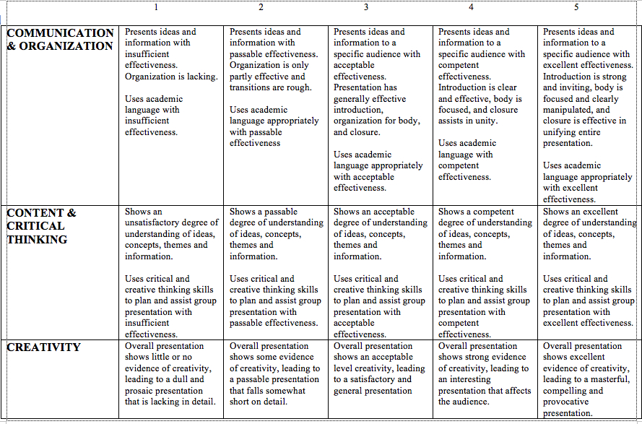
Please ensure –
- You have a cover/title page for your individual report with your name on it.
- Your presentation has a cover/title page and all group members names on it.
- Your presentation has a reference page.
- You number your pages for both the presentation and the report.
- You save your essay in the following format – FULL NAME – MGT205 – ESSAY
- NO PDF SUBMISSIONS!

*Students who are unable to be part of a group, will have to do this whole report as an essay in 2000 words*

*Students who want to present in class; please see me to discuss – I will accept this along with the submissions*

